# **Components:**

**Font:** Yrsa

**Colors:**

# **Mockups / Wireframes:**

## **Mobile:**

- Main and Cart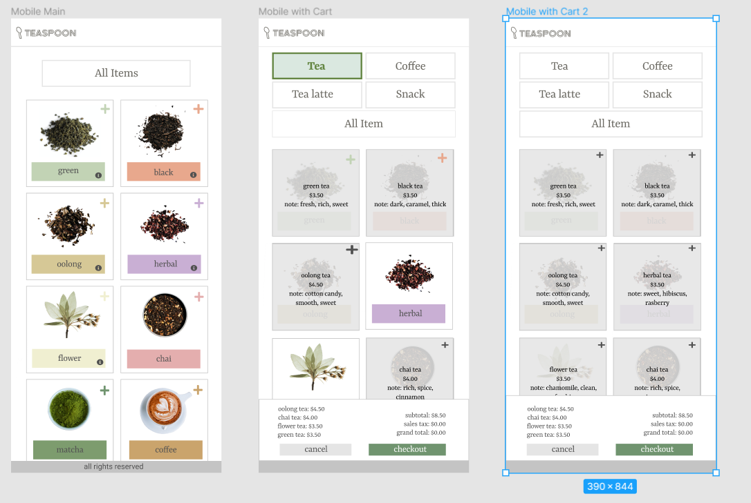

**-** Checkout and Receipt 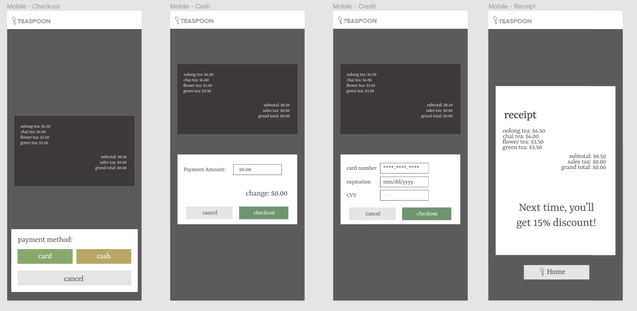

## 

## 

## Desktop:

- Main